Project I & II

1. Objective
Map your home or office network — list every device (router, switches, laptops, phones, printers, smart devices), draw a simple diagram, and label which OSI layer each device primarily operates at.

2. Simple Diagram
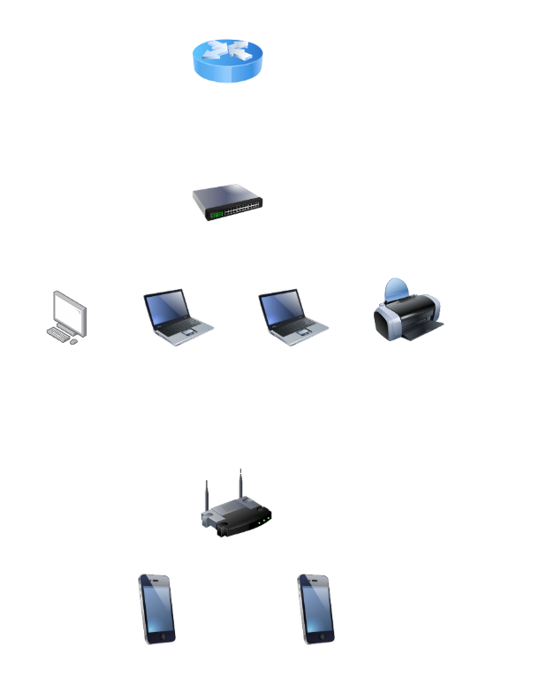

7. OSI Layer Explanation & Mapping

For this project, I created a simple network map representing a typical home or small office network. The network includes a router, switch, PC, two laptops, a printer, a wireless router, and two smartphones. The main router is used to connect the local network to other networks, such as the Internet. The switch connects the wired devices, while the wireless router provides Wi-Fi connectivity for the smartphones.
Each device has a different role in the network. The router mainly works at OSI Layer 3 (Network Layer) because it uses IP addresses to forward data between different networks. The switch mainly works at Layer 2 (Data Link Layer) and uses MAC addresses to forward Ethernet frames to the correct device. The wireless router works mainly with Layers 2 and 3, as it handles wireless connections and IP communication.
The PC, laptops, printer, and smartphones are the end devices in the network. They use multiple OSI layers when communicating, but they are shown mainly at Layer 7 (Application Layer) in the diagram because users interact with applications and network services through these devices. Creating this network map helped me understand how common devices are connected in a home or office network and how each device contributes to communication.

Device | OSI Layer | Role
Router | Layer 3 – Network Layer | Connects the two networks and forwards packets
Switch | Layer 2 – Data Link Layer | Connects PC 1 and PC 2
Wireless Router | Layers 2 & 3 | Provides Wi-Fi and IP connectivity
PC | Layer 7 – Application Layer | End-user computer
Laptop 1 | Layer 7 – Application Layer | End-user computer
Laptop 2 | Layer 7 – Application Layer | End-user computer
Printer | Layer 7 – Application Layer | Provides network printing
Smartphone 1 | Layer 7 – Application Layer | Uses Wi-Fi to access network services
Smartphone 2 | Layer 7 – Application Layer | Uses Wi-Fi to access network services

3. Build the Topology in Packet Tracer
- Place the required devices: one router, one switch, one wireless router, one PC, two laptops, one printer, and two smartphones.
- Connect the main router to the switch using a suitable Ethernet connection.
- Connect the PC, Laptop 1, Laptop 2, and printer to the switch using wired connections.
- Connect the wireless router to the network and use it to provide Wi-Fi connectivity.
- Connect Smartphone 1 and Smartphone 2 to the wireless network.

4. Configure Router R1
Open R1 → CLI and enter:
enable
configure terminal
interface gigabitEthernet 0/0
ip address 192.168.10.1 255.255.255.0
no shutdown
exit
end

5. Configure PC IPv4 Settings
For each PC: Desktop → IP Configuration → select Static and enter the values below.
- PC1: IP 192.168.10.10 | Mask 255.255.255.0 | Gateway 192.168.10.1
- Laptop 1: IP 192.168.10.11 | Mask 255.255.255.0 | Gateway 192.168.10.1
- Laptop 2: IP 192.168.10.12 | Mask 255.255.255.0 | Gateway 192.168.10.1
- Printer: IP 192.168.10.13 | Mask 255.255.255.0 | Gateway 192.168.10.1
- Wireless Router: IP 192.168.10.2 | Mask 255.255.255.0 | Gateway 192.168.10.1

6. Verify End-to-End Connectivity
From PC → Desktop → Command Prompt, run:
ping 192.168.10.1
Then testing the other devices on the network:
ping 192.168.10.11
ping 192.168.10.12
ping 192.168.10.13

then Testing the Wireless router:
ping 192.168.10.2
Testing the smartphones:
ping <smartphone-IP-address>

